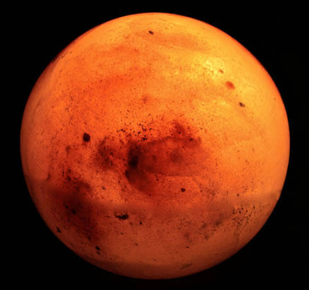 |  |  |  |  | 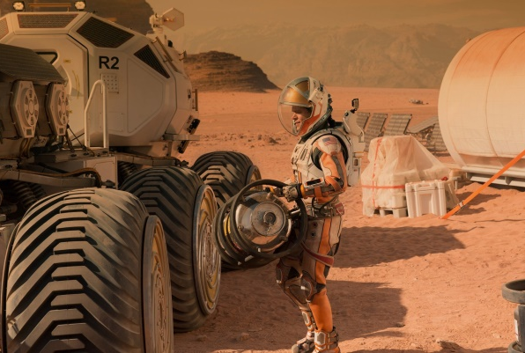
Year 12 Induction 2018
Colonising Mars
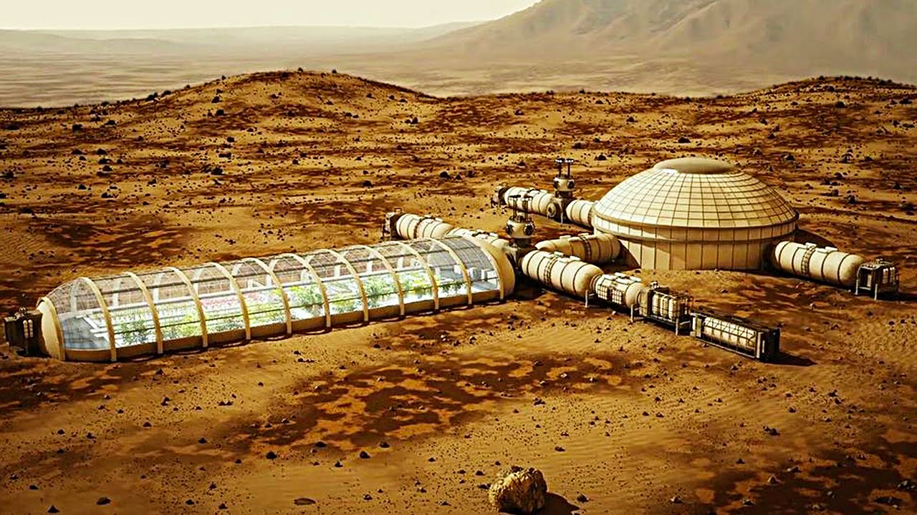
Student |  |  |  | Project Class
Pathway |  |  |  | My Career Aspiration
Dr J.Dyer, Liverpool Life Sciences UTC (dyer.j@lifesciencesutc.net)
@UTCInnovate, http://utcinnovationlabs.blogspot.co.uk,
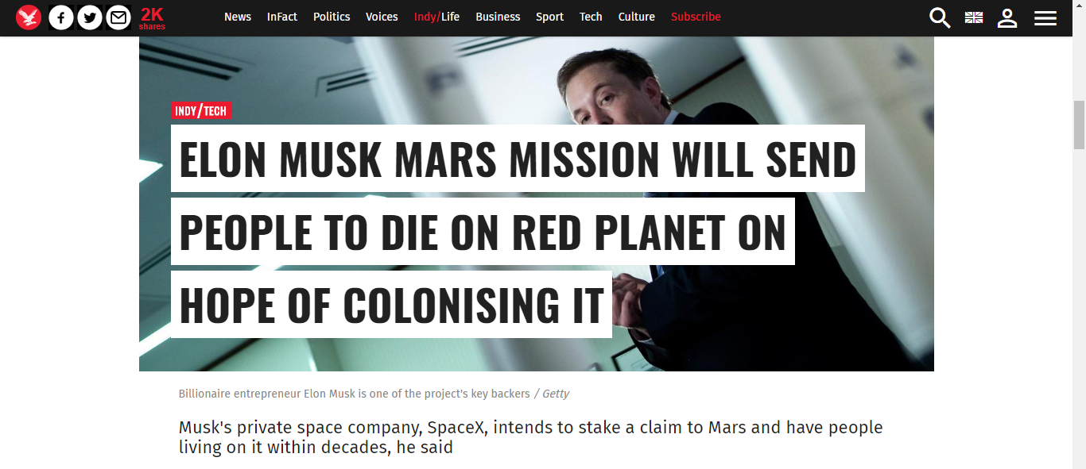
Introduction
Mars. It’s a pretty unforgiving place. On this dry, desiccated world, the average surface temperature is -55 °C (-67 °F). And at the poles, temperatures can reach as low as -153 °C (243 °F). Much of that has to do with its thin atmosphere, which is too thin to retain heat (not to mention breathe). So why then is the idea of colonizing Mars so intriguing to us? There are a number of reasons, which include the similarities between our two planets, the availability of water, the prospects for generating food, oxygen, and building materials on-site. And there’s even the long-term benefits of using Mars as a source of raw materials and terraforming it into a liveable environment.
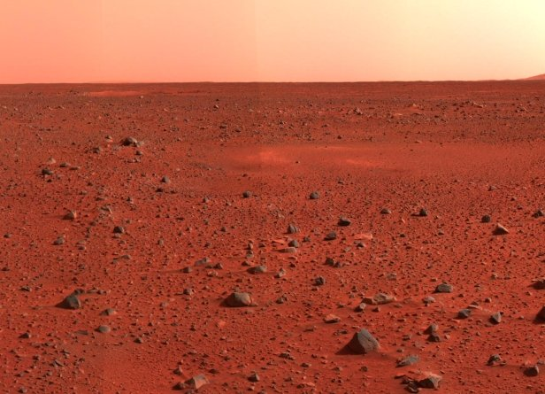
In June 2016, Elon Musk stated the first unmanned flight of the Mars transport spacecraft would take place in 2022, followed by the first manned MCT Mars flight departing in 2024. In September 2016, during the 2016 International Astronautical Congress, Musk revealed further details of his plan, which included the design for an Interplanetary Transport System (ITS) and estimated costs.
There may come a day when, after generations of terraforming and numerous waves of colonists, that Mars will begin to have a viable economy as well. This could take the form of mineral deposits being discovered and then sent back to Earth for sale. Launching precious metals, like platinum, off the surface of Mars would be relatively inexpensive thanks to its lower gravity. Over time, many or all of the difficulties in living on Mars could be overcome through the application of geoengineering (aka. terraforming). Using organisms like cyanobacteria and phytoplankton, colonists could gradually convert much of the CO₂ in the atmosphere into breathable oxygen.
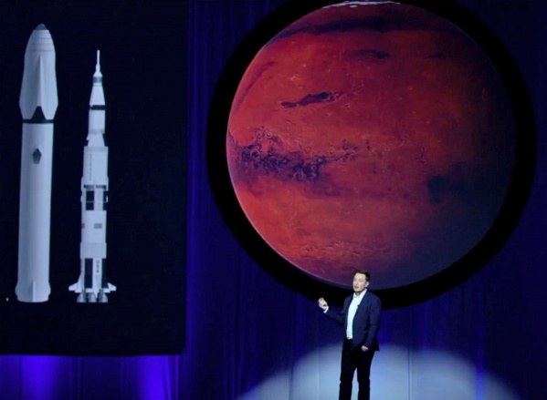
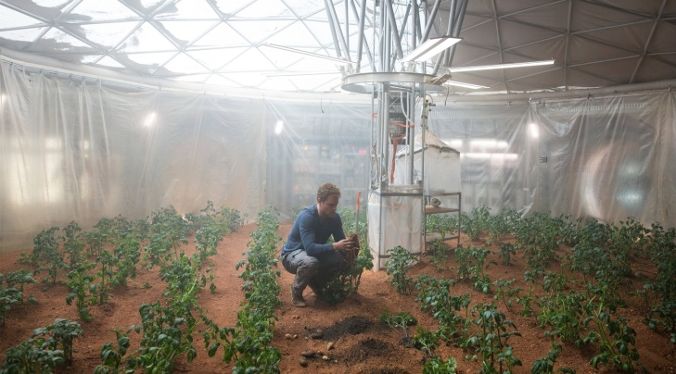
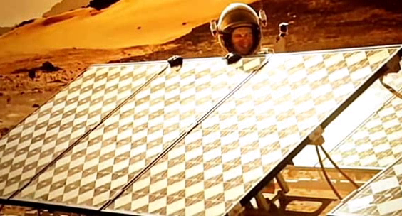
In order to successfully colonise Mars, multidisciplinary teams of scientists will have to work together to solve a number of key problems. This will involve experts in a number of areas, including: Engineers, Mathematicians, Physicists, Chemists, Medics, Biochemists, Molecular Biologists, Botanists, Environmental Scientists, Ecologists and Animal Scientists.
A Multidisciplinary Approach
Many of the global problems that we face can only be tackled using a multidisciplinary approach. This involves researchers from across the different STEM disciplines and beyond working together to solve the problem. The successful colonisation of Mars encompasses many of the problems that we are currently dealing with on Earth, such as increasing food production and making it more sustainable, developing sustainable energy sources and reducing the levels of pollutants in our environment. During this project you will work on two of the tasks below before coming together as a multidisciplinary team to present your findings in a pitch for further research funding.

1. Farming the Red Planet (Biology/Ecology/Env Sci/Chemistry/Geology)

If people are going to live on Mars, then we need to find a sustainable food source. In order for us to successfully grow plants on Mars and produce food and drink that is safe for human consumption we need to know more about the composition of the soil and water on the planet. You will be given samples of Martian soil and water taken from different depths below the surface which you will test to determine their suitability for both growing plants and for consumption. You will perform a series of tests including pH and mineral levels.

The surface of mars is exposed to high levels of UV light which reduce the chances of anything (even bacteria) being able to survive. This means the soil does not contain any of the minerals necessary for plant growth and the bacteria involved in cycling these minerals. During this activity you will have access to some sterile “Mars Soil” which contains very low levels of minerals such as nitrates which are vital to plant growth. You will need to work out how these minerals can be introduced to the Martian soil and how plants can be grown sustainably on Mars. Your time will be split between the labs, where you will analyse Martian soil and the Urban Farm in the Crypt where you will discover more about nutrient cycling and sustainable methods of growing plants.

https://www.livescience.com/52444-growing-food-on-mars.html
https://www.nasa.gov/mission_pages/station/research/news/meals_ready_to_eat
http://www.mars-one.com/news/press-releases/can-bacteria-survive-in-mars-soil-and-thus-enhance-crop-production

http://science.sciencemag.org/content/278/5344/1771.1
https://www.nasa.gov/mission_pages/msl/news/msl20121203.html
http://www.mars-one.com/news/press-releases/can-bacteria-survive-in-mars-soil-and-thus-enhance-crop-production

2. Let them Eat Insects (Animal Science/Biochemistry/Molecular Biology)

As well as crop plants, we are likely to need a reliable protein source. Whilst plant protein is a potential solution, it is also worth considering insect protein as they may be able to be raised on the waste material from plant food production. You will be given a mini mealworm farm and asked to analyse the mealworm as a potential protein source on mars. This will require protein extraction to in order to analyse the amount of protein in a mealworm. You will compare the protein content of insects, such as the mealworm to other potential protein sources including plant-based ones. This will help you make a decision as to what is the best/most sustainable protein source for Mars colonisers.

https://www.space.com/25374-mars-grasshopper-cuisine.html
https://qz.com/805872/insects-bioprocessing-units , https://en.wikipedia.org/wiki/AquAdvantage_salmon
http://www.sandiegouniontribune.com/sdut-genetically-engineered-bacteria-turn-garbage-plast-2011feb24-htmlstory.html
3. Power and Purification (Engineering/Maths/Physics/Chemistry)

a. The only available source of water has been found deep below the surface of the planet and is frozen solid. This Mars ice will need melting (not easy when average temperatures are -60^{O}C) and purifying. You will be given a solid block of Mars Ice from 30m below the surface of the planet. You have to design and build a solar cooker and distillation device in order to heat the ice and purify the water.

https://www.newscientist.com/article/dn8397--radar-reveals-ice-deep-below-martian-surface/
https://www.jpl.nasa.gov/news/news.php?feature=6680
http://www.instructables.com/id/Build-a-simple-parabolic-solar-still/

b. Solar and Wind power are the most viable options for generating power on Mars. However, the wind is only strong enough during a storm when wind speeds can reach up to 60mph.
During this activity students will need to develop and test systems for generating and storing the maximum amount of electricity. You will be given wind turbine kits, solar panels, voltmeters etc and will have to test different designs and combinations of wind and solar to model electricity generation in different conditions on Mars.

https://www.universetoday.com/21293/despite-dust-storms-solar-power-is-best-for-mars-colonies/
http://channel.nationalgeographic.com/mars/videos/generating-power-on-mars/
https://www.nasa.gov/centers/ames/news/releases/2001/01_72AR.html
4. It’s the freakiest show – Is there life on Mars (Medicine/ Healthcare/ Psychology/ Sociology)

The Mars One colonists will be the most isolated humans to have ever lived. Because of their distance from Earth, real time interaction with people back home will be impossible – the shortest delay for sending transmissions will be about 10 minutes. For the rest of their lives they will be able to interact directly with only their fellow colonists, who will increase from three people in the first two years to 23 people after 10 years. These circumstances will probably cause mental illness in at least some of the colonists. Decades of research shows that prolonged social isolation in astronauts can lead to depression, insomnia, anxiety, fatigue, boredom and emotional instability.

Work to determine the key characteristics of suitable applicants to join the programme. Which will be the most important? How will you measure them?

Discuss the psychological consequences of colonisation and how you will work to overcome them.

https://www.theguardian.com/science/head-quarters/2013/sep/09/neuroscience-psychology
https://www.theatlantic.com/technology/archive/2014/04/will-living-on-mars-drive-us-crazy/360034/
https://www.mirror.co.uk/news/world-news/scientists-practice-living-mars-theyve-12050798

5. Staying alive on Mars (Medicine/ Healthcare/ Social Sciences)

The astronauts will be put through many physical checks before they leave. At some point however, an astronaut on Mars will get ill or will be involved in an accident. Medical equipment will be present on Mars and on the way to Mars to treat the most common injuries and illnesses. Two of the four astronauts will have received comprehensive medical training, and the other two will have extensive knowledge of first-aid. All these elements together will provide the group with the tools to help itself. The medical possibilities on Mars will be more limited than those of a modern hospital. Big, heavy equipment won't be present in the settlement for the first few years. Certain conditions will be more difficult or even impossible to treat on Mars.

Consider the most likely health risks to the team. How will you prevent them?
Agree a kit list.
Agree a series of simulations you would need to run ahead of the mission.
Agree a process for preventing the spread of infection between the crew.

https://aeon.co/essays/what-i-ve-learned-so-far-from-living-in-a-mars-simulation

Your Findings

You need to prepare a single A3 sheet and a 2-3 minute talk, summarising your key findings and how they will contribute towards the colonisation of Mars. Use this space to plan your poster and talk.

Additional Notes

